Stereotype: Black students are more prone to get into school trouble than other demographics.

Introduction

Racial inequalities in teacher-issued office punishment referrals are less well-documented than the suspension gaps. Referrals for discipline, such as suspension, might result in lost instructional time. Although kids are sent out of the classroom for a variety of reasons, Black children are more likely than other groups to be sent out. The overrepresentation of black pupils on suspension lists in schools is unquestionably concerning.As new evidence reveals, incarceration has a detrimental influence on high school completion, suspension can lead to dropout. Low accomplishment, dropout, and delinquency have all been connected to future economic challenges, notably in the labor market, as a result of suspension.

Even if the above-mentioned links between suspension and future results aren't totally causal, the presence of racial bias in the application of discipline in public schools is still significant. First, critics of out-of-school punishment frequently point to racial inequity as one of the key reasons for reconsidering the policy. there is a need to raise teacher awareness about negative racial beliefs and the conditions under which those beliefs impact decision-making during discipline incidents. We further point out the need to foster teacher awareness about the power of positive beliefs in affecting student outcomes and the malleability of beliefs and disciplinary practices through intervention.

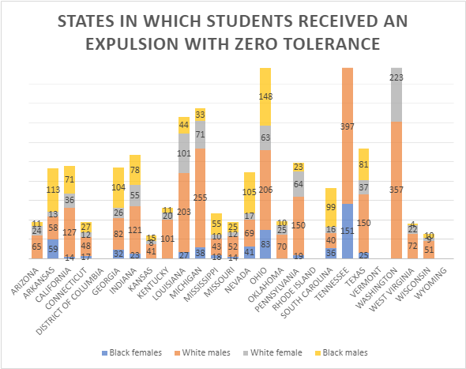

In this graph I used a few states to see how many students of white or black that were expelled with zero tolerance from the years of 2017-18. In this chart the first observation we can make is that white males in Tennessee,Washington,Ohio and Michigan have the highest number of students expelled with zero tolerance compared to that of black males in those states. Whiles looking through this data i also noticed that the number of students for blacks are fairly low amongst most states compared to the whites.

Literature review

student discipline that prohibits students from entering school grounds or participating in any school-related activities for a school-specified number of days. During the 2000 school year, black students comprised 17% of the U.S. student population but accounted for 34% of out of school suspensions. The proportion of black students receiving at least one day of suspension increased by 120% from 1972 to 2000, while for white students, the same measure increased only 64%. The overrepresentation of black students in school suspension rolls is certainly a concern, but equally as troubling is the fact that conditional on a discipline referral, black students tend to receive stiffer penalties than white students. While varying rates of misbehavior across black and white students may explain some of the racial gap in the incidence of suspension, there is no obvious explanation for the gap in discipline conditional on student behavior.

Public concern regarding racial inequality in school discipline stems from the perceived relationship between suspension and a host of undesirable youth outcomes.[4](https://www.sciencedirect.com/science/article/pii/S0272775711001075#fn4) Numerous studies from the education literature document a strong negative correlation between suspension and student achievement.[5](https://www.sciencedirect.com/science/article/pii/S0272775711001075#fn5) While there is little evidence of a direct causal effect, it is widely believed that diminished learning opportunities and a weakening of the student–school bond negatively impact student performance. Dropout rates are also consistently higher for suspended students and some research indicates that schools actually use suspensions to push troublesome students out of school.[7](https://www.sciencedirect.com/science/article/pii/S0272775711001075#fn7) Not only are students excluded from classroom learning while suspended, they may be unsupervised at home and thus more likely to get in trouble in the community. This provides another channel through which suspension can lead to dropout, as recent evidence suggests that incarceration has a negative effect on high school completion. The unfavorable outcomes associated with suspension: low achievement, dropout, and delinquency have all been linked to future economic struggles, particularly in the labor market. **North Carolina student discipline data**

During the 2001 academic year, public schools in North Carolina were required by the state to record all student infractions resulting in out of school suspension.[15](https://www.sciencedirect.com/science/article/pii/S0272775711001075#fn15) For each incident schools had to capture information about the type of infraction, student involved, date of the incident, and school response. To get a sense for the types of misbehavior students participate in, [Table 1](https://www.sciencedirect.com/science/article/pii/S0272775711001075#tbl0005) lists the frequency and average suspension length for the ten most common infractions resulting in suspension during the 2001 school year. Typical adolescent behaviors such as rowdiness and fighting are quite common, while more dangerous behaviors like drug or weapon possession are less frequent.

| **Infraction type** | **Quantity** | **Proportion** | **Mean suspension (days)** | **SD suspension (days)** |
| --- | --- | --- | --- | --- |
| Rule violation | 32,286 | 31.78 | 2.21 | 1.78 |
| Aggressive behavior (fighting) | 28,429 | 27.98 | 3.19 | 2.30 |
| Rowdy (undisciplined) | 22,108 | 21.76 | 2.38 | 1.76 |
| Other | 6,278 | 6.18 | 2.21 | 1.89 |
| Truancy | 4,038 | 3.97 | 2.19 | 1.71 |
| Theft | 2,007 | 1.98 | 2.89 | 2.11 |
| Possession of a controlled substance | 1,408 | 1.39 | 6.59 | 3.17 |
| Substance abuse | 1,168 | 1.15 | 4.46 | 3.03 |
| Possession of a weapon | 1,025 | 1.01 | 5.59 | 3.33 |
| Property damage | 747 | 0.74 | 3.06 | 2.35 |

*Note*: Unit of observation is an infraction resulting in a short-term suspension from school. A short-term suspension is defined as an out-of-school suspension lasting for 10 days or less.

The project objectives The goal of this project is to understand how black students are punished more in school compared to whites

Preliminary project/data questions :

1.What is the percentage of black students enrolled compared to white students?

2. What is the percentage of male and female black students who are disciplined compared to white male and female students?

Data needed to address the project objectives and questions?

1.The number of infractions

2. Number of students

3.Number of students that are female

4.Number of students that are male

5.Total number of students

The Pipeline

Data Ingestion

In order to find out whether the stereotype that black students often get into school issues and disciplinary actions more than whites, to complete this data was used from the CRDC database using data from 2017-2018. The Civil Rights Data Collection (CRDC) is a biennial (i.e., every other school year) survey required by the U.S. Department of Education’s (Department) Office for Civil Rights (OCR) since 1968. Similar to the 2011–12, 2013–14, and 2015–16 CRDCs, the 2017–18 CRDC will collect data from a universe of all public local educational agencies (LEA) and schools, including juvenile justice facilities, charter schools, alternative schools, and schools serving students with disabilities. My analysis will include specific states. This is because the data gathered and virtualized showed that some states don't have the same disciplinary actions and some other states don't have the data entered or not enough students are enrolled.

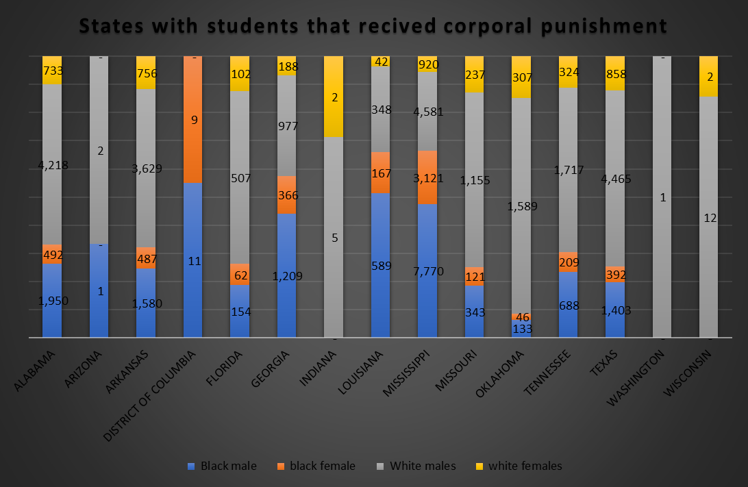

In this figure, the first thing we can notice is that black males in Mississippi, Texas, Georgia, Arkansas, and Alabama have the highest count of corporal punishment. While in those states, you will notice almost both races of males receive more corporal punishment in those states compared to the females. With that observation being made, we can also say that females are less likely to receive corporal punishment compared to their counterparts in race and gender.

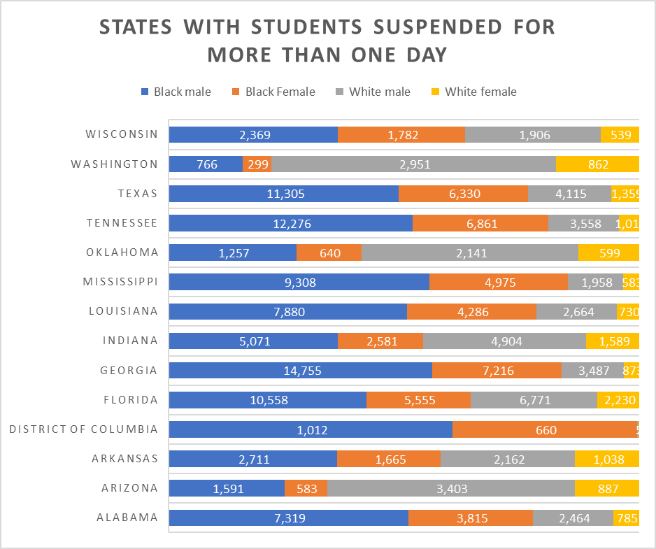

Exploratory data analysis(EDA)

In this chart it shows the count of students that have been suspended for more than one day, The first observation that can be noticed is that in 8 states black males have the highest count of students that are suspended for more than one day. Also for the opposite races we rarely see them hit the 5,000.That mark is only exceeded once in the state of florida with 6,771 in other states the closet they come to this mark is is with 4,115 from the state of texas.With that being said we can see that more black students are suspended more often than white students.

Data Wrangling

For this Report, the 14 states that were selected to be included in the analysis include :Texas,Tennessee,Mississippi,Wisconsin,Louisiana,Alabama,Washington,Oklahoma,indiana,georgia,florida,district of columbia,arkansas and Arizona TheCRDC Database will include two features. These features are the State name and the number of Black and White students involved in disciplinary action . This database will provide a sum count of the male and female black and white students in each state assessed. There were only six instances used from this database. For this report, the CRDC data set was used to identify the students that deal with suspensions and expulsion to determine the count of students that are either white or black either gender to better understand the stereotype. There are over 20 instances in the database. Some background research on each of these states were done to help make conclusions from the data.

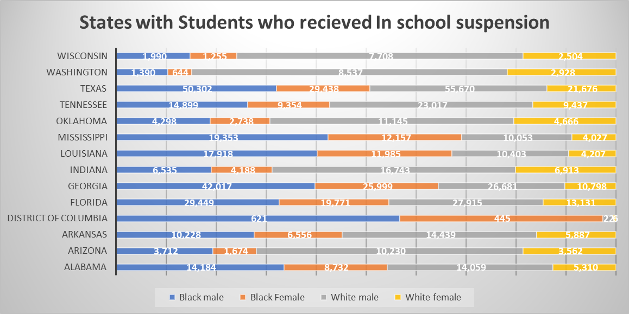

From this data, we can see that Texas and Georgia have the highest count of black males in school suspension when compared to white males. The closest they come to any of those numbers is in Florida, where they are about the same number of students that received in school. suspensions. While the female counterparts have fairly high numbers, they do not come close to the numbers of the black males, but are closer to white males and females, with the highest number for black males being 50,302 students compared to Florida's 27,915 white males. The highest count for black females is 29,438 in Texas, and white females have 55,670, giving them the highest count. Which helps us come to one of many conclusions we could make with this data but from the chart we can see Texas has the highest in school suspension count.

References

Lewin, T. (2012). Black students face more discipline, data suggests. *The New York Times*.

Kinsler, J. (2011). Understanding the black–white school discipline gap. *Economics of Education Review*, *30*(6), 1370-1383.

Blake, J. J., Smith, D. M., Marchbanks, M. P., Seibert, A. L., Wood, S. M., & Kim, E. S. (2016). Does student–teacher racial/ethnic match impact Black students’ discipline risk? A test of the cultural synchrony hypothesis. In *Inequality in school discipline* (pp. 79-98). Palgrave Macmillan, New York.

CRDC datasets